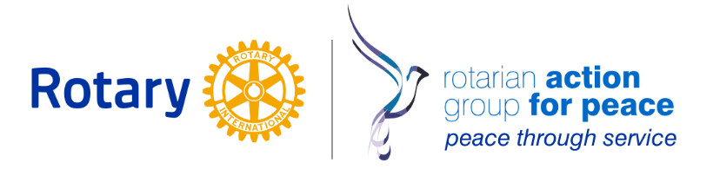

ROTARY ACTION GROUP FOR PEACE DEVELOPMENT OFFICER POSITION

ABOUT THE POSITION
The Rotary Action Group for Peace (RAGFP) is a nonprofit organization based in Portland Oregon with a global outreach. RAGFP empowers and supports the peace work of the global Rotary community by offering structure, guidance, and resources to further their peace efforts.
RAGFP is seeking a contracted development professional, who is able to offer a minimum of 15 hours a week at $50 per hour to help develop and implement a comprehensive, strategic, goal-based fundraising plan to meet the annual financial needs of the organization.
We are seeking a strategic thinker who will leverage the membership of the organization, its leaders, and our global network of peace-minded Rotarians to expand and diversify our funding base. The ideal candidate will be someone passionate about social justice and learning about peaceful solutions to global issues, with an entrepreneurial spirit and desire to grow fundraising efforts to support our peacebuilding activities among our worldwide membership.
This includes donor research and cultivation, with a focus on private donors, foundation grants, Internet-based fundraising, direct mail, and special events, both in-person and virtual.

KNOWLEDGE / SKILLS / ABILITIES
- Candidate must have a proven record of success in the professional environment of philanthropy and fundraising
- Experience with grant writing and proposal development
- Knowledge of fundraising techniques and strategies
- Knowledge and familiarity with research techniques for prospect fundraising
- Willingness and ability to work remotely from home, or post-COVID, in office depending on the demands of the work. Additionally, some travel is likely and should be expected once travel restrictions are lifted. Travel will not be mandatory if any health risks exist.
- Must have the ability to form substantive and productive relationships with people of different backgrounds (i.e., people from other parts of the world who may have cultural differences)
- Ability to work effectively as part of a team and work independently with little supervision. Strong contributor in team environments.
- The successful candidate will have strong written and verbal communication skills; ability to write and present clear, structured, and persuasive proposals to foundation, and individual donor audiences.
- Comfortable with video conferencing and remote office tools.
EDUCATION / EXPERIENCE
- Minimum Bachelor's degree in a related field OR five years in a related field
- Relevant work experience with an emphasis on the professional environment of philanthropy and fundraising.
- Preference for candidates with specific experience in not-for-profit fund development

JOB RESPONSIBLITIES
- Raise funds for the benefit of RAGFP and regularly to meet or surpass fundraising targets
- Research potential donors to gain insight into needs, beliefs and donation habits to understand how to position our organization to them.
- Maintain complete and orderly records of donors and manage regular donor communications.
- Assist in brainstorming and creating new methods to raise funds for our organization
- Leverage technology and social media where possible to improve fundraising activities
- Assist in planning and coordinating events meant to raise funds and coordinate activities of volunteers and interns related to event planning and execution
- Create marketing materials, like flyers and brochures, to be used for the promotion of events and other fundraising pushes
- Analyze the performance of events and other fundraising activities for effectiveness and to identify areas where money can be saved
- Build upon existing donor relationships and form new donor relationships on a regular basis
- Collaborate with other organizations and groups within the community to build partnerships and enhance fundraising activities
Behavioral Competencies
- Passionate about RAGFP’s mission.
- Results driven, proactive and able to work autonomously.
- Ability to work in a fast-paced environment.
- Problem solving aptitude.
- Flexible, change embracing in rapidly evolving work environment.
- Ability to relate to and work with a wide variety of stakeholders.
- Keen interest and commitment to continuous improvement.
- Ability to work cooperatively with others on a team.

If you are qualified and excited about this opportunity, please submit your cover letter, resume, and references to contact@rotariansforpeace.org no later than June 19, 2020.
Due to the large number of applications received, we will be able to follow up with successful applications only.

